  The Road ahead for Ai ehr  How the Microsoft, Amazon and Google architectures differ for Agentic AI Integration. | Abstract  Electronic Health Records have existed for decades now. AI is prompting change and advancement toward an era of endless possibilities for Patients, Clinicians, Payors and Researchers. The foundation of truth in benefits for each segment of the AI EHR Network is whether or not it can stand the test of time and provide improved clinical outcomes for patients and reduce medical staff burnout. What is the road map ahead for an AI EHR architecture that continues to learn and improve results? This research paper presents 4 possible ecosystems using; Microsoft Azure, Amazon Web Services, Google Cloud Platform and InterSystems HealthShare/IRIS capabilities for AI EHR implementation.  John Wolf, MBA CIS, CSM, PMP  The Road Ahead for AI EHR on Microsoft, Amazon, Google and InterSystems HealthShare IRIS Platforms

executive summary
We are still a bridge away from Autonomous Clinical Decision Making, however with the introduction of Kotlin and Kotlin MP we now have a JSON/Kotlin collaborative code path for more reliable software. Quality of code is essential to connecting the Bridge and leveraging GPU Neural Networks into an AI EHR Solution which supports our Doctors, Nurses and Ancillary Clinicians in making the best decisions for courses of treatment for patients. The possibilities are endless. For the scope of this Roadmap Ahead for AI EHR in Clinical Decision Making, we will review the possible architectures showing four different platforms and cloud integration pathways to achieve a robust, scalable and practical AI EHR regardless of the Cloud vendor used of the AI EHR transformation solutions used, although each has its own strengths depending on what the requirements for a project may be.
We will begin with the AWS AI EHR ecosystem and integration design to support clinical decision making and more, followed by Microsoft Azure, Google Cloud Platform and then the InterSystems HealthShare / IRIS IntegratedML solution set. Epic is built on Chronicles, which was built from InterSystems technology and is a High-Performance Computing architecture. A vision of the future is conceptualized here.
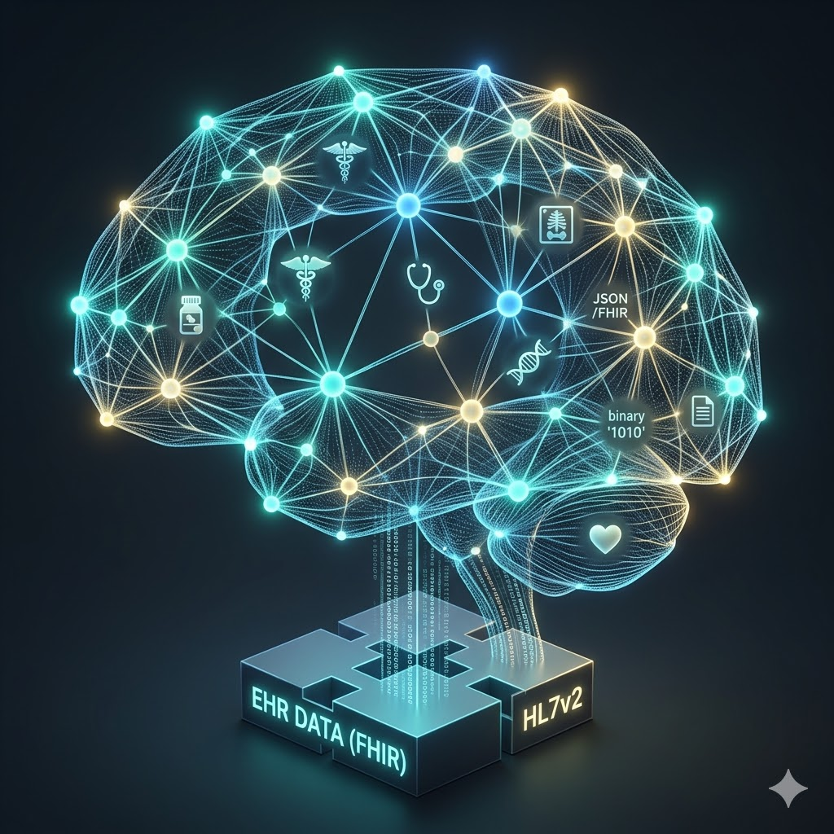

The future of AI EHR information systems using GPU and Neural Networks

Amazon Web Services AI EHR Ecosystem
Integrating AI into Electronic Health Record (EHR) systems using Amazon Web Services (AWS) allows healthcare organizations to transform static data into actionable insights. AWS provides a specialized suite of HIPAA-eligible services designed to handle the complexities of medical terminology, data privacy, and real-time clinical decision support.
At an executive level, this integration typically focuses on three main outcomes: operational efficiency (reducing clinician burnout), improved patient outcomes (predictive analytics), and cost reduction (streamlining billing and administrative tasks). The 100,000 foot view of Amazon’s ecosystem is shown here:

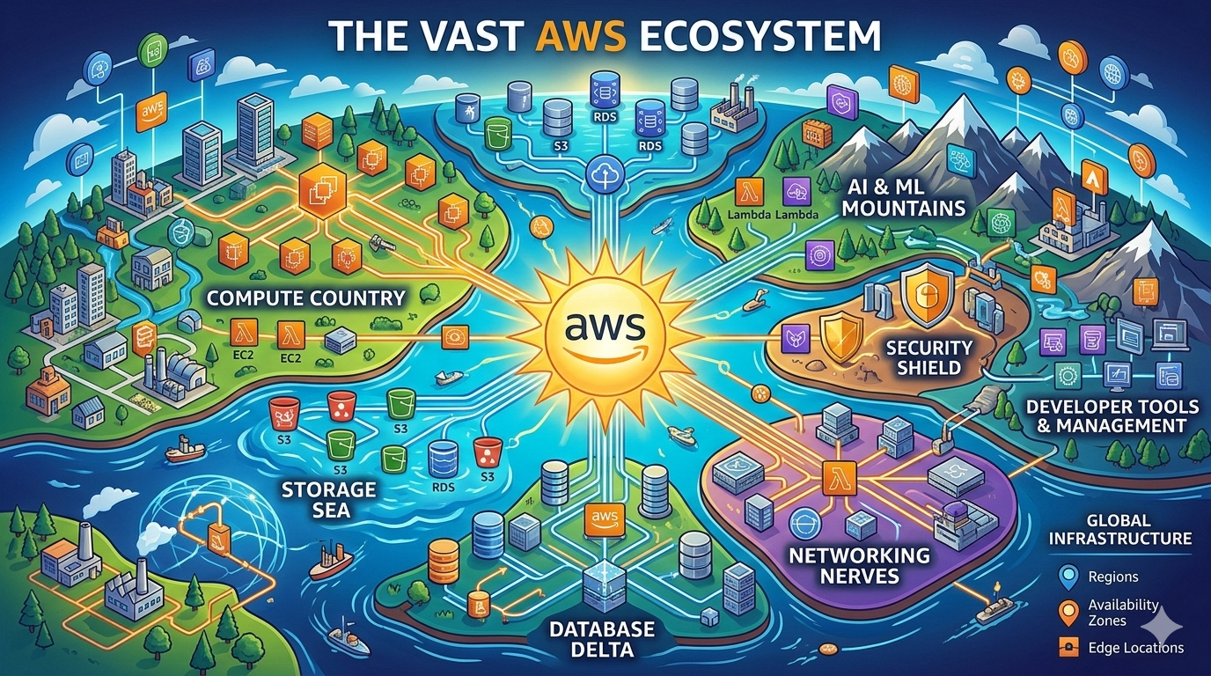
Amazon Web Services AI EHR Ecosystem

Clinical Intelligence & Documentation
Clinical Intelligence is supported by AWS with services like Amazon Comprehend Medical and AWS HealthScribe to automatically extract medical facts from notes or transcribe patient-clinician conversations directly into the EHR.

Predictive Analytics & Population Health
Clinical informaticists and Data analysts should be able to leverage Amazon SageMaker and AWS HealthLake to identify high-risk patients (e.g., predicting sepsis or readmission rates) by analyzing trends across massive datasets.

Security, Compliance, and Interoperability
Security Engineering teams can focus on how AWS manages HIPAA compliance, data encryption, and the FHIR (Fast Healthcare Interoperability Resources) standard to ensure data moves safely between legacy systems and the cloud. The Over View of AWS AI EHR Integration is shown below.

Microsoft Azure AI EHR Ecosystem
Integrating AI into Electronic Health Record (EHR) systems using Microsoft Azure focuses on leveraging a secure, highly scalable cloud infrastructure to enhance clinical decision-making and operational workflows. Azure provides a robust ecosystem, including Azure Health Data Services, which is designed specifically to manage protected health information (PHI) while enabling advanced machine learning and natural-learning capabilities.
For an executive audience, an Azure-based AI integration typically aims to achieve interoperability (connecting fragmented data), clinical efficiency (automating documentation), and patient-centric care (personalized treatment paths). Here is the high level overview of Microsoft’s AI EHR ecosystem below.
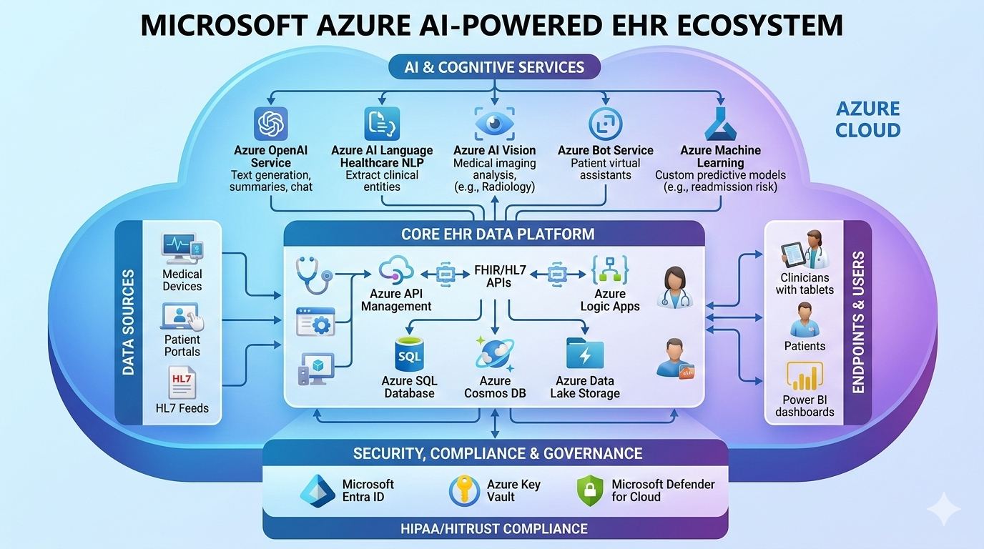
Microsoft Azure AI EHR Ecosystem

2.1 Powered Clinical Documentation
Focusing on DAX (Dragon Ambient eXperience) Express and Azure OpenAI Service allows developers to automate clinical note-taking and summarize patient histories directly within the AI EHR.

2.2 Unified Health Data & Interoperability
Developers may leverage Azure Health Data Services and the FHIR service to ingest, manage, and persist data from disparate sources allows the creation of a "single source of truth" for AI EHR models.

Predictive Insights & Precision Medicine
Using Azure Machine Learning developers can build and deploy models whereby clinical data analytics teams can prompt the AI EHR data to predict patient risks (like chronic disease progression) and Administrators could optimize hospital resource allocation. This would also apply to Use Cases for Medical Supply and Logistics capabilities for just-in-time ordering and fulfillment.

Google Cloud Platform AI EHR Ecosystem
Integrating AI into Electronic Health Record (EHR) systems using Google Cloud Platform (GCP) focuses on turning massive amounts of unstructured medical data and then putting it into organized, searchable, and predictive insights. GCP’s strength lies in its ability to use "search-style" technology to navigate complex patient records and its advanced natural language processing (NLP) models.
For Executives, a GCP-centered approach typically highlights data liquidity (making data flow easily), supporting real-time clinical decision making and operational scale that can handle enterprise-level data safely. Googles AI EHR Ecosystem is shown below:
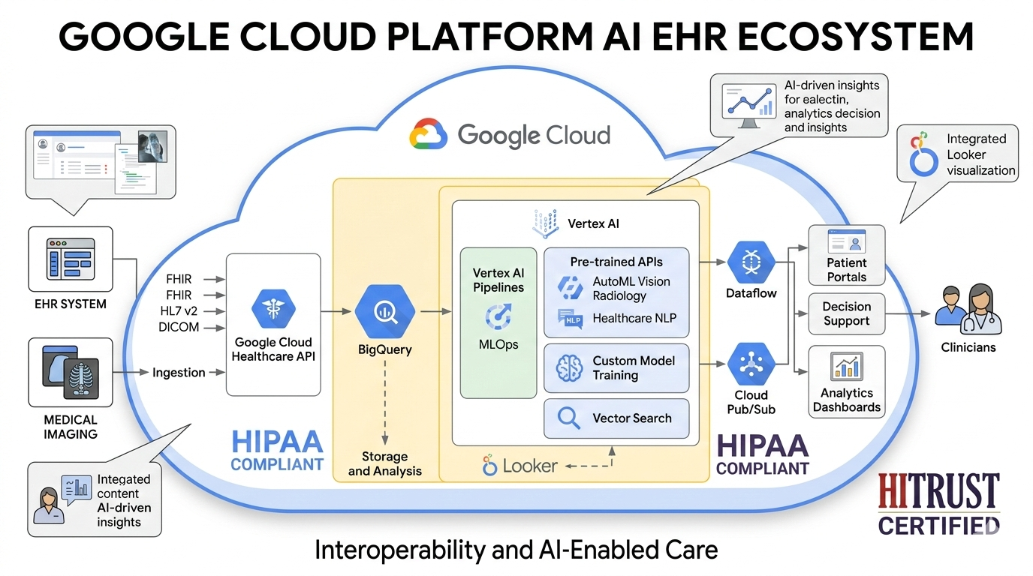
Google Cloud Platform AI EHR Ecosystem

Vertex AI & Generative Insights
Focusing on how Googles Vertex AI Search and Conversation allows clinicians to ask natural language questions about a patient's history (e.g., "Summarize this patient's history of respiratory issues") across the entire EHR. This is a great idea in a perfectly integrated secure architecture where a patients record follows them wherever they go. Take for example, Epic’s “MyChart”. As long as your using an Epic system or a system that has fully integrated with Epic, this capability is achievable. More than likely, inevitably over the course of a patient’s life this is not a realistic expectation unless all EHR systems provide secure “bridge gateways” for patients to opt-in and share their medical history.
As of 2026, Vertex AI has evolved into a comprehensive "AI Factory" on Google Cloud. It is no longer just a place to train models; it is a unified platform that handles everything from Generative AI Agents to enterprise-grade MLOps (Machine Learning Operations).
The platform is essentially divided into three major capability "pillars": Generative AI Studio, Agent Builder, and the MLOps Platform.
3.1.1 Generative AI Capabilities
This is the "Model-as-a-Service" layer where you interact with foundation models without managing the underlying infrastructure.
- Model Garden: A curated library of 200+ models.
  - First-Party: Access to the latest Gemini 3.1 Pro and Flash, which feature a 1M+ token context window and multimodal reasoning (text, audio, video, and code).
  - Specialized Models: Imagen (Image generation), Veo 3.1 (High-fidelity 4K video generation), and Chirp (Speech-to-text).
  - Third-Party & Open: Full support for Llama 3.2, Claude 3.5, Mistral, and Hugging Face integrations.

- Vertex AI Studio: A low-code playground for developers to test prompts, tune model parameters, and manage "Prompt Galleries."
- Tuning & Distillation: Capabilities to fine-tune models using your own data via Supervised Fine-Tuning (SFT) or Reinforcement Learning from Human Feedback (RLHF).
3.1.2 Vertex AI Agent Builder
This is the newest frontier of the platform, designed to move from "chatbots" to autonomous "AI Agents" that can execute real-world tasks.
- No-Code Agent Creation: A visual "drag-and-drop" interface to build agents for customer service, employee onboarding, or knowledge management.
- Grounding with Google Search: A unique capability that allows you to "ground" model responses in real-time Google Search data or your own enterprise data (RAG) to prevent hallucinations.
- Vertex AI Search: A specialized "Google-quality" search engine for your internal documents (PDFs, HTML, BigQuery) that understands semantic intent rather than just keywords.
- Digital Assembly Lines: The ability to link multiple agents together to handle complex, multi-step workflows (e.g., an agent that researches a legal issue, drafts a brief, and emails it to a partner).
3.1.3 Enterprise MLOps Platform
For data scientists building custom models (Predictive AI), Vertex AI provides the "plumbing" to manage the entire lifecycle.
Feature | Purpose
Vertex AI Pipelines | Orchestrates and automates your ML workflows (based on Kubeflow).
Model Registry | A central "library" to version, track, and govern every model in your company.
Feature Store | A centralized repository to share and serve ML features across different teams.
Model Monitoring | Automatically detects "Data Drift" (when real-world data starts looking different than your training data) and sends alerts.
Vector Search | A high-scale engine for "Similarity Search" (finding similar images or text) using billions of data points in milliseconds.
3.1.4 Integrated Data Ecosystem
The "secret weapon" of Vertex AI is its deep integration with the rest of Google Cloud:
- BigQuery Integration: You can run machine learning models directly on your data in BigQuery using BigQuery ML, or use "Zero-copy" integration to train models without moving your data.
- Ray on Vertex AI: Scale your Python and AI applications using the open-source Ray framework for distributed computing.
- Colab Enterprise: A managed version of the popular Colab notebooks, integrated with enterprise-grade security and sharing.
Summary of "Exact" Capabilities by User Type
- Business Users: Build and deploy customer-facing AI agents in minutes using Agent Builder.
- Developers: Access Gemini 3.1 APIs to add multimodal intelligence (video/audio analysis) to apps.
- Data Scientists: Automate the training, deployment, and monitoring of massive custom models at scale.

Healthcare Data Engine (HDE) & Interoperability
Using Google Cloud's Healthcare Data Engine to harmonize data from different sources into the FHIR format allows the creation of a longitudinal record that can be understood and acted upon by Agentic AI agents (see diagram on page 8).

Medical NLP & Imaging AI
Leveraging Healthcare Natural Language API to pull structured data out of messy clinical notes or using Vertex AI to integrate automated medical imaging analysis directly into the clinician's view.
These are the Ecosystems that will be further elaborated in the Architecture Blueprints for each vendors AI generated architecture for implementation. These are ideal views that include the need for other EHR systems to be integrated or accommodated in the best interests of the Patient and the Providers, Clinicians, Pharmacists, Lab Technicians, Pharmacists, Radiologists, Imaging Specialists and Hospital, Clinic and Ancillary Administrators for a true picture of the patient’s longitudinal medical record. In the near future, it is not unrealistic to expect that systems will be transparently transformed to the point at which records are converged via HL7/FHIR/CCDA/X12 Agentic AI Swarms communicating through Secured Access Gateways, Health Information Exchanges and ubiquitous cloud formations working synergistically to collect orphan data based on patient interactions with the AI EHRs that exist within the U.S. and eventually, abroad.
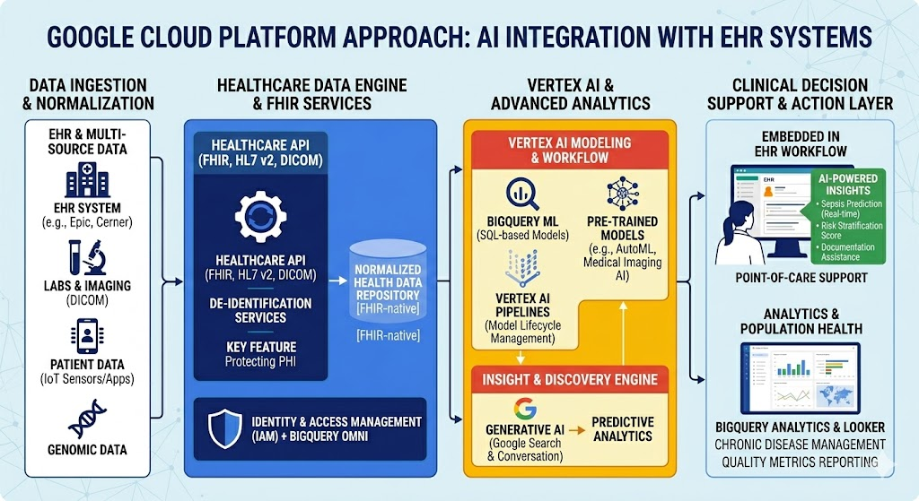
Google Cloud Platform AI EHR Integration Over View

InterSystems IRIS AI EHR Ecosystem
Integrating AI into Electronic Health Record (EHR) systems using InterSystems centers on the power of InterSystems IRIS for Health, a data platform specifically engineered to handle the "cleanliness" and flow of medical information. While cloud providers like AWS or Azure focus on raw computing power, InterSystems excels at data orchestration—ensuring that AI models receive high-quality, normalized data in real-time from fragmented hospital systems.
For Executives, An InterSystems-led strategy emphasizes seamless integration (embedding AI into existing clinician workflows), smart data fabrics (connecting siloed data), and HL7/FHIR native support (reducing the technical debt of data translation). This approach was advocated in 2020 using HealthShare for the VA EHRM Program as the local VistA medical information systems data was made available in real-time to the Cerner Millenium, now Oracle/Cerner cloud. The illustration on the following page describes a high-level view of InterSystems ecosystem .
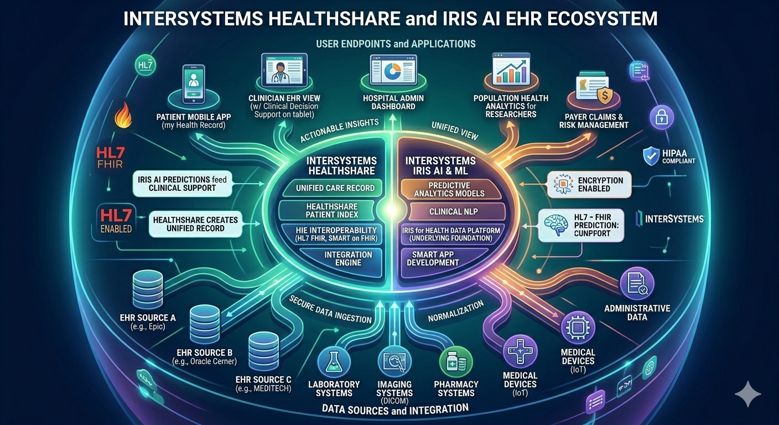
InterSystems HealthShare & IRIS AI EHR Ecosystem

Unified Data Fabric & Interoperability 🧩
With the InterSystems capabilities, it is possible to achieve a Unified Data Fabric that takes advantage of how IRIS creates a "clean" longitudinal record by aggregating data from different sources (Laboratory, Radiology, MRI, Ultrasound and CT imaging, EHR) so that AI models may produce more accurate results. Notice that Pharmacy is not included here because providing historical patient data for a patient who travels abroad (i.e., Active Duty service members, and the population in general which is transitory) will no doubt be stored in more than one EHR. There is no “National EHR”, nor has a truly federated EHR yet to be built that can assure patients and providers of “a lifelong longitudinal EHR” for the care they receive over their lifetime.
Case in point; for example the term "National Drug Repository" is actually a common misnomer. In the United States, there is no single federal database that stores every prescription for every citizen. Instead, what a physician or research analyst will encounter is the interconnected network of state Prescription Drug Monitoring Programs (PDMPs) and the federal laws that have made their use and reporting mandatory for Electronic Health Records (EHRs). (See Appendix A for more on this topic).

IntegratedML (Machine Learning) 🤖
Exploring how IntegratedML allows developers to build and deploy machine learning models directly within the database using simple SQL, making it easier to embed predictive insights into the clinician's daily screen.

HealthShare & Population Health 🌐
Leveraging the HealthShare suite to apply AI across an entire region or Health Information Exchange (HIE) to identify trends in chronic disease or social determinants of health (SDOH) which is a new requirement in CMS USCDI v7.

Epic’s Ecosystem for Sentara Health and CMS🌐
Epic’s ecosystem is orchestrated across a multi-cloud environment. This architecture highlights how Epic transitions from its traditional on-premises roots to Epic on Cloud (using AWS, Azure, and GCP) while maintaining the strict performance and security requirements mandated by its Ours (Database) and Chronicles engines. A Sovereign Mesh AI EHR architecture would leverage the work in place an take advantage to the HPC nature of InterSystems IRIS/Cache’ capabilities.
Sentara Health: The "Chronicles" Vault (Norfolk, VA Hub)
This node is the primary data source for the mesh, demonstrating how a major regional health system anchors its operational core while embracing innovation.
- Epic Chronicles on Azure: The central blue pillar is clearly defined, with a cutaway view highlighting InterSystems IRIS as the hierarchical database engine that houses Sentara's primary EHR Vault.
- Sovereign AI Zones: This node is split into two critical execution environments, which is essential for PHI compliance:
  - Self-Hosted Zone (PHI-Touching): The isolated, translucent blue "cube" where sensitive clinical analysis happens (e.g., Sepsis Prediction or Patient Matching). PHI never leaves this secure Sentara environment.
  - Cloud API Zone (Non-PHI): The lower, grey-and-blue plane that routes administrative and non-clinical tasks to public cloud models (like GPT-4), optimizing performance and cost.
CMS: The Sovereign Fabric (Washington, D.C. Command)
The glowing blue "data-stream core" that dominates the central US is the CMS Sovereign Fabric. This represents the federal oversight that "dissolves" traditional boundaries, enabling:
- Identity & Trust: A common framework that connects regional nodes (like Sentara) to the federal level.
- The Federal Vault: Where aggregated, standardized data is stored for value-based care and population health analysis.
Multi-Cloud Resiliency & Interoperability
The mesh isn't just conceptual; it’s a tangible multi-cloud reality.
- AWS (Interoperability Zone): The green node in the Pacific Northwest demonstrates how AWS hosts auxiliary services like the Hyperspace/Hyperdrive presentation layers, VNA storage, and AWS HealthLake for FHIR-formatted population health analytics.
- GCP (Analytics Zone): The orange node in the Southwest highlights Google Cloud’s specialty in large-scale data science, showing data moving to BigQuery and Vertex AI for deep longitudinal research and SDOH analysis.
The Agentic SDLC
The swirling, glowing energy patterns surrounding the Sentara Vault represent the Agentic workflows and Linter Swarms. This is the Process Architecture that governs the factory line, ensuring that the Terraform IaC, post-Go-Live optimizations, and security patches are automatically generated, audited for compliance, and deployed with zero-day reliability.

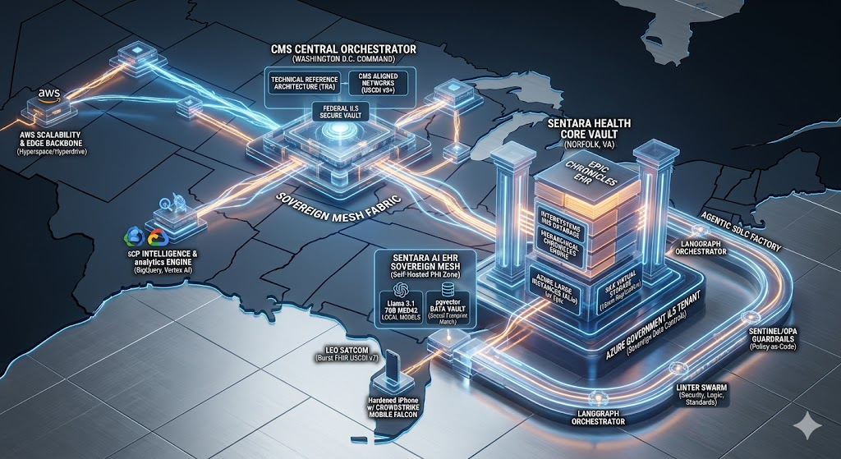
Epic Multi-Cloud Architecture for Sentara Health
Microsoft Azure is currently the most mature "home" for Epic cloud deployments due to their long-standing strategic partnership.
The Core: Epic on Azure (The Primary Hub)
- Infrastructure: Utilizes Azure Large Instances (ALIs) to run the massive Epic InterSystems IRIS/Caché database workloads that require high IOPS.
- Management: Employs Azure Monitor for Epic to track real-time health across the database and application tiers.
- Innovation: Deep integration with Microsoft DAX Copilot for ambient clinical intelligence and AI-assisted documentation.
The Scalability Engine: Epic on AWS
AWS provides the high-availability "backbone" for many of Epic's auxiliary and presentation services.
- Application Tier: Uses Amazon EC2 to host the Hyperspace/Hyperdrive presentation layers and Web Blob servers.
- Storage: Leverages Amazon S3 for long-term storage of VNA (Vendor Neutral Archive) medical images and cold-storage patient records.
- Data Liquidity: Connects via AWS HealthLake to normalize and store FHIR-formatted data for population health analytics.
The Intelligence Layer: Epic on GCP
Google Cloud is often utilized as the specialized "intelligence" arm of the Epic ecosystem, focusing on large-scale data science.
- Analytics: Ingests Epic data into BigQuery via the Google Cloud Healthcare API to perform petabyte-scale longitudinal research.
- AI/ML: Uses Vertex AI to train predictive models (e.g., sepsis prediction or readmission risk) that are fed back into the Epic workflow as In Basket notifications.
- Interoperability: Facilitates secure data exchange between Epic and external payor systems using Google's Apigee API management.

Multi-Cloud Integration Strategy
In a multi-cloud Epic environment, the "connective tissue" is critical to ensure a unified user experience:
- Identity: A unified Azure Active Directory (Entra ID) usually manages identity across all three clouds for Single Sign-On (SSO).
- Interconnect: High-speed, private links (e.g., AWS Direct Connect, Azure ExpressRoute, GCP Interconnect) ensure sub-millisecond latency between the Epic database on Azure and analytics workloads on GCP.
- Data Standard: All three providers utilize HL7 FHIR (v4.0.1) and USCDI standards to ensure that a patient record looks the same regardless of which cloud is processing it.

1. The Active Swarm: Four Specialized Agents
- Security Agent: The first robot is deep in a 'FIPS 140-3 Compliance Scan' on IaC Terraform. It has found a 'CRITICAL VULNERABILITY' (an open egress rule). Critically, it does not just fail; it provides the Actionable Fix: 'Limit to Azure Private Link.'
- Logic/Edge-Case Agent: The next agent analyzes the 'Burst FHIR Ingest' logic. It identifies a potential system failure: a 'LOGIC GAP' during a LEO comms drop-out. The Fix: 'Implement exponential backoff.'
- Standards Agent: This agent validates the data against Sentara’s Specific FHIR Implementation Guide (IG) and USCDI v7. It catches a missing optional resource, ensuring perfect data alignment.
- Documentation Agent: Finally, this agent checks the README and comments. It identifies that the developer failed to update the change log (v2.3), enforcing architectural hygiene.
2. The Consensus Loop & Data Maturation
All four agents feed into the 'AGENT CONSENSUS & CODE MATURATION REPORT'. The swarm cannot deploy code that has not passed every gate.
- Overall Score: 88%: This is a great score, but the swarm is relentless.
- REJECTED (FAILED ON SECURITY & DOCS): The swarm blocks the deployment gate because of the open egress rule and missing change log.
- TO SANDBOX DEPLOYMENT GATE (Blocked): This shows the value of the sandbox. The non-compliant code is contained, and the PR is automatically sent back to the developer with the Delta Analysis and specific fixes.

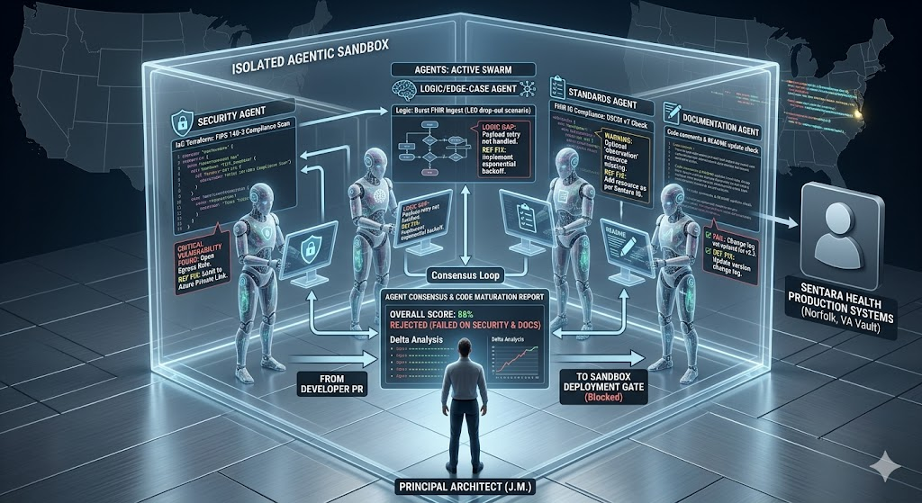
Agentic “Linter Swarm” for new AI models and agents for Epic Sentara Health EHR data pulls

Amazon web services AI EHR Integration Architecture

Amazon Web Services (AWS)
Strategic Focus: AWS provides a high-performance "clinical assembly line." Its primary focus is on modularity, scale, and enabling large health systems and health-tech developers to build highly customized, specialized AI models from scratch using a comprehensive suite of cloud-native tools.

Approach & Distinguishing Strengths:
- Highly Specialized, Modular NLP: AWS HealthScribe and Amazon Comprehend Medical are powerful, focused tools for clinical transcription and medical concept extraction (e.g., RxNorm, ICD-10-CM).
- The Model Builder's Platform: Amazon SageMaker is arguably the most flexible and mature platform for developers to build, train, and deploy their own specialized machine learning (ML) models, from simple logistic regression to large generative AI models.
- Ecosystem Depth: For organizations requiring total control over data infrastructure and access to the widest variety of distinct cloud services (e.g., compute, storage, networking), AWS offers the most robust catalog.
The AI EHR Architecture for AWS is shown here for reference as the specific components of the modular design will be discussed in more detail below.
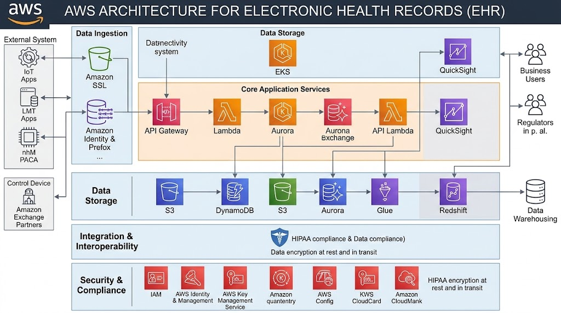
Amazon Web Services AI EHR Integration
Amazon Redshift itself has evolved into a powerful "ELT" (Extract, Load, Transform) engine that does a lot of the heavy lifting for data preparation Instead of preparing data before it hits the warehouse, modern architectures use Redshift's massive compute power to prepare it inside the warehouse. Here is how that works:

Zero-ETL and Seamless Ingestion
Redshift has moved away from complex, manual pipelines.
- Zero-ETL Integrations: You can now stream data directly from Amazon Aurora, RDS, and DynamoDB to Redshift in near real-time without writing any ETL code.
- Streaming Ingestion: It ingests data directly from Kinesis Data Streams or MSK (Managed Streaming for Apache Kafka) allows software engineers to prepare and analyze live data as it arrives.
- The COPY Command: This remains the gold standard for bulk loading data from S3, as it parallelizes the ingestion process across all compute nodes.

Redshift Spectrum (The "Lake House" Pattern)
You don’t always have to load data to prepare it. With Redshift Spectrum, you can query and join data directly in your S3 data lake using standard SQL. This is perfect for:
- Pre-filtering massive datasets before loading.
- Joining "cold" historical data in S3 with "hot" data in Redshift for unified preparation.

In-Database Transformations (The ELT Flow)
Once data is in (or visible to) Redshift, you use SQL to transform it:
- Materialized Views: These are a game-changer for prep. You can pre-compute complex joins and aggregations, and Redshift can automatically refresh them when the underlying data changes.
- Stored Procedures: These allow you to encapsulate complex transformation logic, making it repeatable and easy to schedule.
- Federated Query: You can reach out and query operational databases (like a Postgres production DB) to pull in reference data for preparation without a formal ETL step.

Autonomics and Optimization
As of 2026, Redshift has leaned heavily into Autonomics. It can now automatically allocate extra compute resources for background optimizations (like table sorting and statistics updates) without slowing down your analysts' queries.
Pro-Tip for 2026: If you are using custom preparation logic, remember that Python UDFs are reaching end-of-support by June 30, 2026. AWS recommends migrating that logic to Lambda UDFs for better scalability and security.
Setting up a Zero-ETL integration is a powerful way to get your operational data into Redshift without the "technical debt" of traditional ETL pipelines.
Since Aurora MySQL is the most common use case, the process is outlined below. The steps for RDS and Aurora PostgreSQL are very similar, but they require specific parameter tweaks.

Step 1: Prepare the Source (Aurora/RDS)
Zero-ETL relies on the database's binary logs (binlogs) to stream changes. You must enable this by creating a custom parameter group.
- Create a Custom Parameter Group: Go to the RDS Console -> Parameter Groups and create a new DB Cluster Parameter Group.
- Modify Parameters: Search for and set the following:
  - aurora_enhanced_binlog = 1 (or ON)
  - binlog_format = ROW
  - binlog_checksum = NONE
- Apply & Reboot: Associate this parameter group with your Aurora cluster and reboot the writer instance to activate the changes.

Step 2: Prepare the Target (Redshift)
Redshift needs to be told to "accept" the incoming data and handle it correctly.
- Enable Case Sensitivity: Zero-ETL requires your Redshift cluster or Serverless workgroup to have enable case sensitive identifier set to true.
  - Note: This is a permanent change for the workgroup, so double-check if your existing queries depend on case-insensitivity.
- Authorize the Source:
  - Go to the Redshift Console -> Namespace -> Resource Policy.
  - Select Add authorized principal and enter your AWS Account ID.
  - Select Add authorized integration source and paste the ARN of your Aurora Cluster.

Step 3: Create the Integration
Now, you create the actual "bridge" between the two services.
- Navigate to the RDS Console -> Zero-ETL integrations.
- Click Create Zero-ETL integration.
- Source: Select your Aurora cluster.
- Target: Select your Redshift namespace/workgroup.
- Data Filtering (Optional): You can choose to include or exclude specific databases or tables here.

Step 4: Finalize in Redshift
Once the integration state moves to Active, the data is technically there, but you need to "mount" it as a database in Redshift.
Open the Redshift Query Editor v2 and run:

2026 Pro-Tips
- Latency: Expect a "p50" lag of about 15 seconds. For massive bursts of data (1M+ transactions/min), this might climb slightly but usually recovers quickly.
- Schema Changes: Adding a column in Aurora is "Zero-ETL friendly"—it will appear in Redshift automatically. However, changing a data type (e.g., INT to VARCHAR) can sometimes break the sync for that specific table.
- Cost Management: Monitor your RPU (Redshift Processing Unit) usage. Large initial syncs can spike RPU consumption; consider setting a usage limit in Redshift Serverless to prevent budget surprises.
Monitoring a Zero-ETL integration from the Redshift side is critical for ensuring data consistency. You don't manage the underlying replication "job," but you can see exactly where it is, how far it's lagging, and if it's encountered any issues.
Here are the essential SQL commands to keep in Redshift to check the health and performance of your Aurora or RDS integration.

Integration Status and Overall Health
This query is your first stop for a high-level overview. It tells you if the integration itself is healthy and the absolute minimum replication lag.

Detailed Replication Lag
This is the "is my data up-to-date?" query. It shows you exactly how far behind the source your Redshift cluster is.

Table-by-Table Breakdown
This query is invaluable if you are seeing errors or suspect specific tables are not syncing. It gives a detailed status per table.

Historical Replication Errors
If the table status query in #3 shows ERROR, this view provides a log of the last few errors Redshift encountered.

2026 Pro-Tips for Monitoring
- Alerting is Key: Don't manually run these queries. Use CloudWatch Alarms on the ReplicationLag metric for your integration. Set a threshold (e.g., 300 seconds) and have it send an SNS topic alert.
- Initial Sync is "Special": During the very first sync, min_replication_lag_seconds can be very high and fluctuate wildly as Redshift loads the bulk of your data. This is normal and will settle down once the initial sync is complete.
- The "ERROR" State: If a table moves to an ERROR state, it means that table is no longer sinking. Redshift will not retry automatically. You must typically troubleshoot the issue (often a schema mismatch) and then reset the table sync from the Redshift integration side.
When you compare major cloud providers (AWS, Azure, Google) with InterSystems for EHR AI integration, you are contrasting two distinct architectural philosophies: the "Cloud Toolkit" approach versus the "Native Data Fabric" approach.
All four platforms share the goal of transforming EHR data into predictive clinical insights. They all support the FHIR (Fast Interoperability Healthcare Resources) data standard, offer massive computing power, and leverage specialized healthcare natural language processing (NLP) to structure medical notes.
The differences lie in their primary strategic focus, where they begin the data journey, and how deeply they integrate with the active clinical workflow.

Microsoft Azure
Strategic Focus: Microsoft Azure’s approach focuses on minimizing the technical gap between data management and sophisticated modeling. Its primary focus is on workflow efficiency, leveraging its pervasive presence in both clinical desktops and enterprise identity management to create a frictionless path from data ingestion to clinician insight. An All View of Azure’s infrastructure can be utilized for AI EHR integration is shown here:

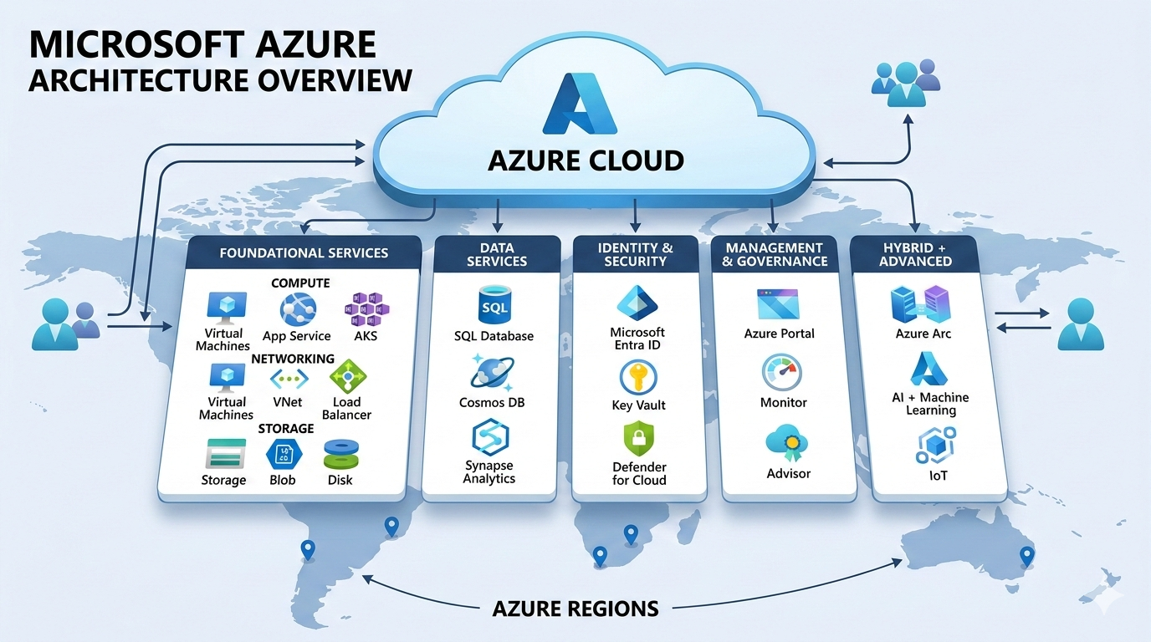
Microsoft Azure Architecture

Approach & Distinguishing Strengths:

Workflow Productivity (The DAX Advantage)
Azure’s acquisition of Nuance is a unique advantage. By blending Azure OpenAI Service with Dragon Ambient eXperience (DAX) Express, Microsoft has a market-leading ambient clinical intelligence solution that automatically generates clinical notes for immediate review within the EHR, significantly reducing documentation burden.

Unified Enterprise AI
Through Azure AI Studio, organizations can easily build, test, and deploy models from a single hub. Azure simplifies the process of making different AI systems (like medical imaging analysis and population health models) work together.

Native Interoperability
Azure Health Data Services is designed to simplify the persistent storage and real-time exchange of healthcare data, particularly FHIR, reducing the complex integration work typically required to connect siloed EHR systems.

Google Cloud Platform (GCP)
Strategic Focus: Google Cloud Platform applies its heritage in search and large-scale data analysis to the healthcare landscape. Its primary focus is on data liquidity and semantic discovery, making massive amounts of unstructured, siloed EHR data easily searchable, organized, and available for complex analysis. Google’s overarching strategy and architecture are shown here:
Google Cloud Platform AI EHR Integration

Approach & Distinguishing Strengths:
Healthcare Data Engine (HDE): This is a standout feature. HDE automates the ingestion, normalization, and semantic mapping of data from multiple sources (labs, imaging, pharmacy) into a single, comprehensive "longitudinal record." This makes data immediately "AI-ready" for advanced models.
Google’s Healthcare Data Engine (HDE) is an enterprise-scale "factory" that automates the process of turning messy, siloed clinical data (HL7v2, CSVs, etc.) into a unified, high-quality Longitudinal Patient Record (LPR) using the FHIR R4 standard.
In 2026, it is primarily used to "ground" AI models like Gemini to ensure they make clinical decisions based on a patient’s actual history rather than hallucinated data.

1. The Core Workflow: From "Silo" to "Insight"
The engine works in four distinct stages:
Stage 1: Multi-Protocol Ingestion
HDE ingests data from disparate sources using the Cloud Healthcare API.
- HL7v2: Real-time clinical feeds (ADTs, Lab results, Pharmacy orders).
- DICOM: Medical imaging data.
- Batch Data: Historical records in CSV or custom formats stored in Cloud Storage.
Stage 2: The Mapping Engine (Whistle/Data Mapper)
The most complex part of the process is the translation. HDE uses a low-code tool called Data Mapper IDE to map legacy data into FHIR.
- Automated Mapping: Out of the box, it maps over 90% of HL7v2 messages from leading EHRs (like Epic and Cerner) directly to FHIR R4.
- Data Harmonization: It reconciles duplicate records (e.g., matching "Jon Doe" from the pharmacy to "John Doe" from the ER) to create a single "Source of Truth."
Stage 3: The Longitudinal Patient Record (LPR)
Instead of just storing separate events, HDE builds a chronological timeline of the patient’s health. This data is stored in a FHIR Store, which is a high-performance, REST-compliant database.
Stage 4: Downstream Activation
Once the data is in FHIR format, it is automatically streamed to two main destinations:
- BigQuery: For large-scale SQL analytics, population health reporting, and risk modeling.
- Vertex AI Search for Healthcare: This is the 2026 "killer feature." It allows clinicians to ask natural language questions (e.g., "Does this patient have a history of cancer?") which the AI answers by searching the verified LPR.

2. HDE vs. Healthcare API: What’s the Difference?
It is common to confuse these two, but they serve different purposes:
Feature | Cloud Healthcare API | Healthcare Data Engine (HDE)
Role | The Storage & Interface layer. | The Intelligence & Transformation layer.
Function | Provides the REST API to read/write FHIR. | Automates mapping, de-duplication, and LPR creation.
Technical Level | Requires custom code to map data. | Low-code/Automated mapping out of the box.
Pricing | Pay-per-request / GB. | Managed service with pipeline-based pricing.

3. Key 2026 Security & Compliance Features
- De-identification API: Automatically scrubs PHI (Protected Health Information) from datasets so researchers can use real clinical data without violating HIPAA or GDPR.
- Regional Isolation: Data is stored in specific geographic regions (e.g., us-central1) to meet data residency laws.
- Lineage Tracking: In 2026, HDE provides "Audit-Ready AI," meaning you can track exactly which original HL7 message or lab report led to a specific AI-generated summary.

Sample HL7-to-FHIR mapping script:
To see how the engine actually works, you have to look at Whistle, the domain-specific language Google created for healthcare mapping.
In a real-world scenario, if a hospital sends a "Patient Admit" (ADT_A01) message via HL7v2, the engine runs a script that breaks down the raw pipe-delimited text and builds a structured FHIR JSON object.
1. The Input: Raw HL7v2 (ADT_A01)
The engine receives a message like this from the EHR: Plaintext
MSH|^~\&|EPIC|HOSPITAL|||202603091415||ADT^A01|12345|P|2.3
PID|1||8675309^^^MRN||DOE^JOHN^LEO||19890429|M|||1234 MAIN ST^^MORRISVILLE^NC^27560
2. The "Whistle" Mapping Script
This is a simplified version of the code that lives inside Google’s Data Mapper. It defines how specific segments (like PID) map to FHIR resource fields.
Code snippet
// Whistle Mapping for HL7v2 to FHIR Patient package hl7_to_fhir_mapping
// Define the root transformation
def ADT_A01_to_Patient(msg) {
var pid = msg.PID;

// Construct the FHIR Patient Resource
resourceType: "Patient"
id: pid.3.1 // Uses MRN as the ID

// Map Name (PID-5)
name[]: XPN_to_HumanName(pid.5)

// Map Gender (PID-8)
gender: Convert_Gender(pid.8)

// Map Birth Date (PID-7)
birthDate: Convert_DateTime(pid.7)

// Map Address (PID-11)
address[]: XAD_to_Address(pid.11)
}

// Helper function for Name structure
def XPN_to_HumanName(xpn) {
family: xpn.1
given[]: xpn.2
given[]: xpn.3
prefix[]: xpn.5
}

// Helper for Gender terminology translation
def Convert_Gender(code) {
if code == "M" then "male"
else if code == "F" then "female"
else "unknown"
}
3. The Output: Structured FHIR JSON
The engine executes the script above and outputs a valid FHIR R4 resource, which is then stored in the FHIR Store and made searchable.
JSON
{
"resourceType": "Patient",
"id": "8675309",
"name": [
{
"family": "DOE",
"given": ["JOHN", "LEO"]
}
],
"gender": "male",
"birthDate": "1989-04-29",
"address": [
{
"line": ["1234 MAIN ST"],
"city": "MORRISVILLE",
"state": "NC",
"postalCode": "27560"
}
]
}

- Why this matters for our AI EHR architecture:
- Scalability: This process happens in milliseconds via Cloud Dataflow, allowing you to process thousands of patient updates per second.
- Grounding: Because the data is now in a standard JSON format, you can point a Gemini AI model at this Patient record. Instead of the AI guessing, it can read the address and birthDate directly from this verified FHIR resource.
- Reconciliation: If another message arrives from a different system (e.g., a lab) with slightly different name spelling, the engine's "Match & Merge" rules can automatically link them to this same Patient ID.

Match & Merge rules to prevent duplicate patient records in the AI EHR Hub
In Google’s Healthcare Data Engine, the "Match & Merge" process is handled by the Entity Resolution service. This is critical because a single patient might have an "Admission" record in the EHR, a "Lab Result" in a separate LIS system, and a "Pharmacy" record—often with slight variations in name, address, or phone number.
The engine uses a combination of Deterministic and Probabilistic rules to ensure these records are linked to a single "Golden Resource."

The Configuration: Defining "Matching Rules"
You configure these rules within a JSON-based policy file. The engine looks for "Identifiers" that suggest two records are the same person.

Example: Tiered Matching Strategy
A robust 2026 configuration usually follows a three-tiered approach:
- Tier 1 (Exact Match): If Social Security Number (SSN) or Medical Record Number (MRN) matches exactly.
- Tier 2 (High Confidence): If Last Name + Date of Birth + Zip Code match exactly.
- Tier 3 (Fuzzy Match): If Last Name is phonetically similar (e.g., "Smith" vs "Smyth") and the Phone Number matches.

2. Sample Match & Merge Policy (JSON)
This is a simplified representation of how the engine evaluates whether to "Link" a new incoming record to an existing one.
JSON
{
"entityType": "Patient",
"rules": [
{
"ruleName": "Strict-ID-Match",
"matchingFields": ["identifier.ssn", "identifier.mrn"],
"action": "AUTO_MERGE",
"confidenceThreshold": 1.0
},
{
"ruleName": "Demographic-Fuzzy-Match",
"matchingFields": ["name.family", "birthDate", "address.postalCode"],
"algorithms": {
"name.family": "SOUNDEX",
"address.postalCode": "EXACT"
},
"action": "LINK_AND_REVIEW",
"confidenceThreshold": 0.85
}
]
}

3. The Merge Workflow
When the engine detects a match, it performs the following steps:
- Selection of the "Survivor": The engine determines which record is the most "trusted." For example, data from the primary the EHR usually overrules data from a third-party lab app for example.
- Field-Level Merging:
  - Single-value fields: It keeps the most recent or most trusted value (e.g., current Address).
  - Multi-value fields: It appends new information (e.g., keeping a list of all known phone numbers).
- The Linkage (Link Resource): Instead of deleting the old record, the engine creates a Link attribute in the FHIR resource. This maintains the "lineage," so you can always see where each piece of data originated.

4. Preventing "Over-Merging"
A major risk in healthcare is "Colliding" two different people (e.g., twins living at the same address). To prevent this, the engine uses Negative Constraints:
- The "Anti-Match": If the First Names are significantly different (e.g., "John" vs "James") despite the same Last Name and DOB, the engine will flag the record for manual human review rather than merging automatically.

Architectural Impact
By implementing these rules, the FHIR-compliant hub ensures that when a clinician or an AI agent queries a patient's history, they are seeing a complete, unified timeline rather than fragmented pieces of a puzzle.

Manual Review" dashboard for hospital staff to resolve the high-risk "near matches" that the AI flags:

In Google's Healthcare Data Engine (HDE), the "Manual Review" process is managed through a specialized Stewardship Portal (often referred to in 2026 as the Data Quality Hub).
This dashboard acts as a safety valve for "Near Matches"—situations where the AI is fairly confident two records are the same person but hasn't reached the 95–99% threshold required for an automatic merge.

The "Inbox" of Potential Conflicts
When a conflict occurs (e.g., two "John Does" with the same DOB but different middle initials), the system creates a Task in the portal. A Data Steward (typically a health informatics specialist) sees a prioritized list:
- High Risk: Potential "Collisions" (merging two different people).
- High Value: Potential "Fragmentation" (missing a crucial lab result for a patient because it's under a slightly different name).

The Side-by-Side Comparison UI
The dashboard provides a "Difference Highlighter" to help the steward make a split-second decision.
Field | Existing Record (EHR) | Incoming Record (Lab) | Status
Name | John L. Doe | John Leo Doe | MATCH (Fuzzy)
DOB | 1989-04-29 | 1989-04-29 | MATCH (Exact)
Address | 10520 Chapel Hill Rd | 10520 Chapel Hill Rd | MATCH (Exact)
Phone | (919) 555-1234 | (919) 555-9876 | CONFLICT
Steward Action: The steward can see that the address and name match perfectly, but the phone number has changed. They can select "Merge & Update Phone" with one click.

3. Key 2026 Capabilities of the Hub
- AI-Assisted Recommendations: The dashboard doesn't just show the data; it uses a Gemini-powered summary to explain why it flagged the record. (e.g., "Flagged: Patient has a twin 'James Doe' at this address; confirm middle initial before merging.")
- "Explainable" Lineage: Stewards can click on any data point to see the "Source of Truth." It will show the exact HL7 message or CSV file that provided that specific piece of information.
- Bulk Resolution: If a specific system (like a new pharmacy partner) is consistently sending "Doe, John" instead of "John Doe," the steward can create a pattern-based rule to fix all current and future matches from that source instantly.

4. Closing the Loop: The "Golden Resource"
Once the steward hits "Approve," the engine:
- Updates the FHIR Store: Merges the records into a single Patient resource.
- Notifies Downstream Apps: If you have an AI-driven "Patient Chart" app, it immediately receives a notification that the record has been updated, ensuring the doctor always sees the most accurate data.

Summary of the Workflow
- AI Engine: Identifies a 85% match.
- Stewardship Portal: Generates a review task.
- Human Steward: Validates the match using side-by-side visual tools.
- Final Merge: The "Golden Record" is published to the FHIR hub.
Stewardship Workflow for your AI EHR Project
How do we advise our client to decide which staff members should have the authority to approve these merges?
Designing a stewardship workflow for a healthcare hub in 2026 requires balancing automated speed with clinical accountability. Because you are dealing with Protected Health Information (PHI), the hierarchy of who can approve a merge is as much about legal compliance (HIPAA/GDPR) as it is about data accuracy.
Here is a 2026-standard design for your Stewardship Workflow.

1. The Three-Tiered Authority Model
In a modern health system, you shouldn't give everyone "Merge" power. Access should follow the Principle of Least Privilege.
Role | Persona | Responsibility | Permission Level
Data Owner | Chief Medical Officer (CMO) | Sets the "Thresholds" (e.g., "AI must be 98% sure to auto-merge"). | Policy Level (Accountable)
Lead Steward | Clinical Informatics Lead | Resolves complex conflicts (e.g., twins with similar names). | Full Merge/Unmerge Authority
Operational Steward | Registrar or Health Information Mgmt (HIM) | Resolves daily demographic mismatches (e.g., misspelled addresses). | Limited Merge (Demographics only)

2. The Workflow Logic: "Traffic Light" Triage
The engine automatically categorizes incoming data conflicts based on a "Confidence Score" generated by your matching algorithms.

🟢 Green: Auto-Merge (No Human Required)
- Criteria: Confidence Score > 98%.
- Example: Exact match on MRN, SSN, and Last Name.
- Action: The record is merged instantly. An audit log entry is created.

🟡 Yellow: Prompted Review (Operational Steward)
- Criteria: Confidence Score 85% – 97%.
- Example: Matching DOB and Address, but the name is "Jon" vs "Jonathan."
- Action: The record sits in the Steward’s "Review Inbox." The Steward compares them side-by-side and clicks "Approve."

🔴 Red: High-Risk Escalation (Lead Steward)
- Criteria: Conflicting critical data or "Anti-Match" flags.
- Example: Same name and DOB, but different Blood Types or conflicting Allergy lists.
- Action: Locked for standard staff. Only a Lead Steward or Clinician can resolve this, as a mistake here could lead to a medical error.

3. Setting Up the "Review Inbox" in Google Cloud
To build this, you would typically use Google Cloud IAM roles integrated with the HDE stewardship portal.
- Task Creation: When a "Yellow" or "Red" match occurs, HDE triggers a Pub/Sub message.
- Notification: A Cloud Function picks up that message and creates a ticket in your stewardship tool (e.g., ServiceNow, JIRA, or a custom AppSheet dashboard).
- The Decision: The Steward reviews the Lineage (where the data came from). In 2026, the AI adds a "Reasoning Note" to the ticket:
"Recommended Action: Merge. Probability 91%. Justification: Address and Phone match exactly; 'Jon' is a common nickname for 'Jonathan'."

4. Safety "Kill Switches" & Audit Trails
In 2026, every manual merge must be Traceable and Reversible.
- Immutable Logs: Every time a human clicks "Approve," the system logs their User ID, the timestamp, and the specific fields they chose as the "Truth."
- The "Unmerge" Button: If a steward realizes they accidentally merged two different people, the system must support a one-click "Rollback" that restores both original FHIR resources.

Summary Checklist for Your Workflow
- [ ] Identify your Stewards: Who in your organization is actually allowed to touch patient records?
- [ ] Define your "Auto-Merge" Threshold: Is 95% enough, or do you want 99%?
- [ ] Set up Escalation Paths: What happens if a steward is unsure? (Usually, it goes to the Clinical Informatics head).
- [ ] Enable Logging: Ensure all manual actions are exported to BigQuery for monthly compliance audits.
Would you like me to draft a "Standard Operating Procedure" (SOP) template that you can give to your staff to explain how to handle these manual reviews?

- Vertex AI & Generative Insights: GCP excels at natural language understanding and search. Its flagship AI platform, Vertex AI, combined with products like Health-Specific Generative AI, allows clinicians to use conversational "Google-like" search queries directly over patient history, quickly locating specific trends (e.g., "Summarize this patient's history of respiratory infections").
- BigData Analytics: For organizations focused on large-scale population health, GCP's BigQuery and Looker tools provide powerful, scalable solutions for analyzing massive datasets to identify trends and optimize resource allocation.

InterSystems HealthShare / IRIS for Health
Strategic Focus:
InterSystems takes a fundamentally different approach. It is not a cloud infrastructure provider, but a high-performance data platform engineered specifically for the healthcare sector. Its primary focus is data orchestration—becoming the normalized "single source of truth" that manages the flow and cleanliness of medical information before it is handed off to any AI model, whether built natively or by an external cloud provider. The way that this works is represented in the illustration below:
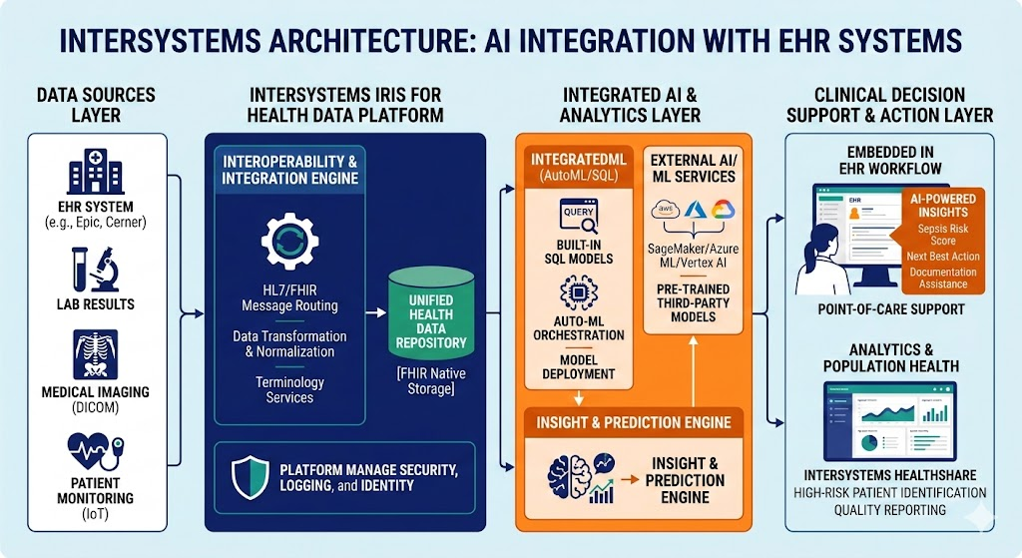
InterSystems Overview for AI EHR Integration
Approach & Distinguishing Strengths:
- Native Interoperability (Data Fabric): Unlike the cloud toolkit approach, which extracts and stores data in a new data lake, InterSystems acts as an active data fabric. It manages real-time HL7 and FHIR connectivity with existing hospital legacy systems (Epic, Cerner, labs), ensuring data normalization, patient matching, and identity resolution at the source.
- IntegratedML: To reduce the dependency on specialized data scientists, InterSystems provides IntegratedML. This tool allows developers to build and deploy sophisticated machine learning models (e.g., predicting readmission risk) directly inside the database using simple SQL commands, without complex data pipelines.
- Deep Integration with EHR: Because InterSystems IRIS often already functions as the active interoperability layer for health systems, it is exceptionally easy to embed AI-generated insights (e.g., sepsis scores, next best actions) directly into the existing clinician workflow screen (point-of-care).

Summary of Key Differences
Feature/Focus | AWS | Microsoft Azure | Google Cloud Platform | InterSystems
Philosophical Approach | Cloud Toolkit: Modularity & scale for custom building. | Unified Workflow: Enterprise productivity & AI assistance. | Data Liquidity: Semantic search, discovery & big data analysis. | Data Orchestration: High-performance data platform & integration fabric.
Starts Data Journey at... | Data Storage (AWS HealthLake) | Interoperability Layer (Health Data Services) | Normalization (Healthcare Data Engine) | Connection to Source (HL7/FHIR Connectivity)
Unique Core Component | Amazon SageMaker: Flexibility for model development. | DAX Express / OpenAI: Integrated clinical note generation. | Vertex AI Search & Conversation: Medical insight discovery. | IntegratedML (SQL-based): Simplified ML for developers.
Best For Organizations... | Wanting highly customizable, specialized AI build capabilities. | Prioritizing clinical productivity & ambient documentation. | Focused on multi-source data harmony & complex search/discovery. | Need high-performance, real-time data orchestration and embedded workflow insights.

Appendix A – Pharmacy Records across the nation

The term "National Drug Repository" is actually a common misnomer. In the United States, there is no single federal database that stores every prescription for every citizen. Instead, what you are likely referring to is the interconnected network of state Prescription Drug Monitoring Programs (PDMPs) and the federal laws that have made their use and reporting mandatory for Electronic Health Records (EHRs).
Here is the breakdown of the actual laws and the systems that track medications across the nation.

A1. The Law: The SUPPORT Act
The primary law mandating that EHRs report prescriptions and making that data available nationally is the SUPPORT for Patients and Communities Act, originally passed in 2018 and officially reauthorized in December 2025 (H.R. 2483).
- EPCS Mandate: Section 2003 of the original 2018 Act required all clinicians to use Electronic Prescribing of Controlled Substances (EPCS) for all Medicare Part D prescriptions. This effectively forced EHR vendors to build reporting "on-ramps" to state
- Interoperability: The 21st Century Cures Act (2016) and the HITECH Act (2009) further mandated that EHRs must be "interoperable," meaning they must be able to share data with other systems (like pharmacies and state databases) without "information blocking."

A2. The "National Database": PDMPs and InterConnect
Pharmacy Prescription data is made available to pharmacies nationwide through a system of "hubs."
- State PDMPs: Every state (except Missouri, which uses a different model) has a Prescription Drug Monitoring Program (PDMP). These are electronic databases that track controlled substances (Schedules II–V).
- PMP InterConnect: This is the "bridge" that makes the data national. Operated by the National Association of Boards of Pharmacy (NABP), it links nearly all state PDMPs together. When a pharmacist in Maryland checks a patient's history, they can see if that patient also filled a script in Virginia or California.
- RxCheck: This is a second federal hub (funded by the DOJ) that allows for secure, cross-state sharing of prescription data between state and federal agencies.

A3. How Medications Are Tracked
Depending on what you are looking for, "tracking" happens in three different ways:
System | Purpose | What is Tracked?
PDMP / InterConnect | Patient Safety & Abuse Prevention | Controlled substances (Opioids, ADHD meds, etc.) tied to a specific patient name.
Surescripts | Electronic Prescribing | All prescriptions (including antibiotics, blood pressure meds). This is a private network that EHRs use to send orders to pharmacies.
DSCSA (Track & Trace) | Supply Chain Security | Physical bottles/boxes. The Drug Supply Chain Security Act (DSCSA) mandates that every unit of medicine has a unique serial number so its path can be traced from the factory to the pharmacy shelf.

Building a prototype AI EHR App for Pharmacy RxHx
The key components and technologies required to build an AI-powered Electronic Health Record (EHR) application for reporting pharmacy prescriptions based on patient history.

AI EHR App for Pharmacy Prescriptions: Full Stack Overview
Building an AI-powered Electronic Health Record (EHR) application for reporting pharmacy prescriptions based on patient history requires a robust and secure full stack. Here's a breakdown of the essential components, leveraging Google Cloud's capabilities in Healthcare and Life Sciences (HCLS):

Data Ingestion & Integration
This layer focuses on securely bringing in and standardizing diverse patient data.
Component | Description | Google Cloud Services
EHR Systems | Existing Electronic Health Record systems, often the primary source of patient data. | Healthcare API, Cloud Interconnect, Cloud VPN
Pharmacy Data Feeds | Data from pharmacies, including prescription details, dispensing history, and drug information. | Pub/Sub (for real-time feeds), Cloud Storage (for batch files)
Lab Results | Structured and unstructured lab data relevant to patient history and prescription efficacy. | Healthcare API, Cloud Storage
IoT/Wearables | Data from patient monitoring devices, if applicable. | IoT Core, Pub/Sub
Data Normalization | Processes to standardize data formats (e.g., FHIR, HL7v2) for interoperability and consistency. | Healthcare API (for FHIR/HL7v2), Dataflow
Security & Compliance | Ensuring all data handling adheres to healthcare regulations (e.g., HIPAA). | Cloud Identity and Access Management (IAM), Cloud Key Management Service (KMS), Security Command Center

Data Storage & Management
Secure and scalable storage solutions are critical for handling sensitive patient information.
Component | Description | Google Cloud Services
Raw Data Lake | Storage for all incoming, unrefined data. | Cloud Storage
Structured Data Warehouse | Optimized for analytical queries and structured patient history. | BigQuery (for large-scale analytics)
Operational Database | For real-time application data and transactional operations. | Cloud SQL, Cloud Spanner (for global scale)
Document/Image Storage | For unstructured data like scanned prescriptions, doctor's notes, or medical images. | Cloud Storage
Master Patient Index (MPI) | A system to uniquely identify and link patient records across different data sources. | Cloud Spanner, Custom solution on Compute Engine/GKE

AI & Analytics Core
This is where patient history is processed, analyzed, and AI models are applied to inform prescription reporting.
Component | Description | Google Cloud Services
Data Processing | Cleaning, transforming, and preparing data for AI model training and inference. | Dataflow, Dataproc, Spark on Compute Engine/GKE
Feature Engineering | Creating relevant features from raw data for AI models (e.g., drug-drug interactions, patient comorbidities). | Vertex AI Feature Store
AI Model Training | Developing and training machine learning models to identify prescription patterns, predict adverse events, or suggest optimal dosages based on patient history. | Vertex AI (for model development, training, and deployment), AutoML (for pre-trained models)
Natural Language Processing (NLP) | Extracting insights from unstructured text data in patient charts and notes (e.g., medication adherence, side effect reporting). | Cloud Natural Language API, Vertex AI NLP services
AI Model Deployment & Serving | Hosting and managing AI models for real-time inference and batch predictions. | Vertex AI Endpoints
Explainable AI (XAI) | Providing transparency into AI model decisions, crucial for clinical applications. | Vertex AI Explainable AI
Reporting & Insights Engine | Generating prescription reports and insights based on AI model outputs and historical data. | BigQuery (for analytics), Looker Studio (for dashboards)

Application Layer & User Interface
This layer provides the interface for healthcare professionals to interact with the EHR system and view prescription reports.
Component | Description | Google Cloud Services
Web/Mobile Application | The user-facing application for doctors, pharmacists, and other clinicians. | App Engine, Cloud Run, Google Kubernetes Engine (GKE)
APIs | Secure endpoints for other applications or third-party systems to interact with the EHR data and AI services. | Apigee API Management, Cloud Endpoints
User Authentication & Authorization | Secure access control for different user roles. | Cloud Identity and Access Management (IAM)
Front-end Frameworks | Modern web frameworks for building interactive user interfaces (e.g., Angular, React, Vue.js). | (Deployed on App Engine/Cloud Run/GKE)

Security, Compliance & Operations
Underpins the entire stack, ensuring data integrity, patient privacy, and operational reliability.
Component | Description | Google Cloud Services
Regulatory Compliance | Adherence to healthcare-specific regulations like HIPAA, GDPR, etc. | Google Cloud's commitment to HCLS compliance, Security Command Center
Logging & Monitoring | Tracking system performance, user activity, and potential security threats. | Cloud Logging, Cloud Monitoring, Cloud Trace
Backup & Disaster Recovery | Strategies to ensure data availability and business continuity. | Cloud Storage, Firestore Backup/Restore, Database backups
Network Security | Protecting network traffic and access to resources. | Virtual Private Cloud (VPC), Cloud Armor, Cloud DNS
Data Governance | Policies and procedures for managing data lifecycle, quality, and access. | Data Loss Prevention (DLP) API

This comprehensive stack allows for secure, scalable, and intelligent management of patient prescription data, helping to improve patient safety and optimize treatment outcomes.

full stack required for AI EHR pharmacy prescription reporting
This solution outlines how to build an AI-powered Electronic Health Record (EHR) application to report pharmacy prescriptions for patient history, leveraging Google Cloud's specialized healthcare services and AI capabilities. The combination of Google Cloud Healthcare Data Engine for secure and compliant patient data management, Vertex AI platform for intelligent data processing and insights, and Firebase App Hosting for a robust frontend provides a comprehensive and scalable architecture. This approach ensures that sensitive healthcare data is handled appropriately while enabling advanced AI functionalities to extract and present relevant prescription information.

Step-by-Step Guide to Build the Solution:

- Set up Google Cloud Healthcare Data Engine: Utilize the Google Cloud Healthcare Data Engine to ingest, store, and manage patient health records, including pharmacy prescription data, in a compliant manner using FHIR, HL7v2, or DICOM standards.
- Store sensitive data securely: Use Secret Manager to securely store any API keys, credentials, or other sensitive configuration data required by the application or AI models.
- Prepare data for AI: Store relevant datasets for AI model training and inference in Cloud Storage. This could include de-identified prescription data or patient history.
- Develop and deploy AI models: Use the Vertex AI platform to develop, train, and deploy AI models. These models could be designed to extract specific information from patient records, identify patterns in prescription history, or even generate summaries.
- Manage ML artifacts: Utilize Artifact Registry to store and manage container images for your AI models, as well as other ML artifacts like trained models and datasets, ensuring version control and reproducibility.
- Implement serverless logic: Use Cloud Run for deploying containerized microservices that interact with the Google Cloud Healthcare Data Engine and the Vertex AI platform. This could include services for data preprocessing, triggering AI inference, or formatting results.
- Build the application frontend: Host the EHR application's frontend using Firebase App Hosting. This will provide automated deployment and infrastructure for a modern web application.
- Integrate frontend with backend: The Firebase App Hosting will likely interact with the Cloud Run services to fetch and display patient prescription data and AI-generated insights.
- Monitor and log: Implement Cloud Monitoring to track the performance and health of your application, AI models, and underlying infrastructure. Use Cloud Logging to collect and analyze logs from all components for troubleshooting and auditing.
- Ensure network security: Configure Virtual Private Cloud (VPC) to establish a secure and isolated network environment for your Google Cloud resources, especially for sensitive healthcare data.
- Automate with SDK: Use Cloud SDK for programmatic interaction with Google Cloud services, automating tasks like data ingestion, model deployment, and application updates.
Insightful questions to help the user clarify their requirements and refine the solution:
- What specific types of pharmacy prescription data need to be reported (e.g., medication names, dosages, dates, prescribing physician)?
- What are the primary use cases for the AI in this EHR app (e.g., identifying drug interactions, predicting medication adherence, summarizing prescription history)?
- What are the expected data volumes for patient records and prescription data?
- What are the real-time processing requirements for prescription reporting?
- Are there any specific compliance requirements beyond HIPAA that need to be considered for data handling and reporting?
- What is the desired user interface and user experience for the EHR application?
- What level of explainability is required for the AI's recommendations or insights regarding prescriptions?

Where to get Pharmacy Test Data
Google Cloud offers access to significant pharmacy-related data, primarily through the following:

RxNorm Dataset
Google Cloud Marketplace provides the RxNorm public dataset, created by the U.S. National Library Of Medicine (NLM). this dataset offers a standardized naming system for clinical drugs, encompassing:
- Ingredients
- Strength
- Dose Form
- Brand Names
- Drug Classes
This data is updated and archived monthly and is available as BigQuery tables. It is useful for tasks such as navigating between drug vocabularies, assisting with e-prescribing, drug analytics, and formulary development.

FDA Drug Dataset
A sample notebook illustrates the use of the FDA dataset available in BigQuery (bigquery-public-data.fda_drug) for tasks like generating prescription drug names. This dataset can be queried to access information such as generic names, brand names, and indications & usage for over 100,000 drugs.

Cloud Healthcare API
The Google Cloud Healthcare API facilitates the secure storage, management, and integration of various healthcare data types, which can include prescription information. This API supports industry standards such as:
- Fast Healthcare Interoperability Resources (FHIR)
- Health Level Seven International Version 2 (HL7v2)
This allows for the creation of systems that can store and process prescription data in a compliant manner.
These resources enable various applications, from drug name generation and research to clinical and operational analytics in healthcare and life sciences.

SOP: Patient Record Reconciliation & Manual Review
This Standard Operating Procedure (SOP) template is designed to help the team manage patient identity and data reconciliation within the Google Cloud Healthcare Data Engine (HDE) framework
Document ID | HDE-STW-001 | Effective Date | March 09, 2026
Owner | Clinical Informatics Lead | Version | 1.0
Scope | All HDE Data Stewards | Status | Active

Purpose
To standardize the process of resolving patient identity conflicts (potential duplicates or overlays) identified by the HDE Entity Resolution service. This ensures a unified "Golden Record" for every patient while maintaining clinical safety.

Roles & Responsibilities
- Data Steward (L1): Performs daily review of "Yellow" (High Confidence) matches. Validates demographic updates (addresses, phone numbers).
- Lead Data Steward (L2): Resolves "Red" (Conflicting) matches involving critical clinical data (DOB mismatches, blood type conflicts).
- Clinical Informaticist: Final arbiter for cases where data suggests two different patients have been incorrectly merged ("Over-merge").

Triage & Prioritization
Stewards must check the Data Quality Hub daily. Tasks are prioritized as follows:
- Critical (Anti-Match): Discrepancies in birth date or biological sex.
- High (Conflict): Discrepancies in clinical identifiers (e.g., conflicting MRNs).
- Medium (Ambiguous): Name variations (e.g., "Jonathan" vs "Jon") with matching addresses.

Step-by-Step Procedure

Step A: Access the Stewardship Portal
- Log in to the Cloud Healthcare Data Engine console.
- Navigate to the Entity Resolution > Pending Reviews dashboard.
- Select a task from your assigned queue.

Step B: Side-by-Side Analysis
- Review the Match Score and AI Reasoning Note (e.g., "Confidence: 92% based on exact address match; phonetic name match").
- Compare the "Survivor" (current Golden Record) against the "Incoming" (newly ingested) record.
- Check for "Twin Flags": Verify if the patients share a DOB and Last Name but have different First Names or Middle Initials.

Step C: Decision & Action
- Action 1: MERGE. Use if you are 100% certain the records represent the same person. Select the most current demographic data to persist in the Golden Record.
- Action 2: LINK ONLY. Use if the records are likely the same person but contain significant data discrepancies that require further clinical verification.
- Action 3: REJECT/DISCARD. Use if the records are definitely two different individuals. This prevents a "Collision."

Step D: Verification & Documentation
- Enter a brief justification in the Audit Note field (e.g., "Confirmed via phone number match with existing EHR record").
- Click Apply Change. The FHIR Store will update the Patient resource and its link attribute.

Exception Handling
- Accidental Merge: If an "Over-merge" occurs, the Lead Steward must initiate a Rollback/Unmerge task. Notify the Clinical Informaticist if the erroneous data was accessed by a provider during the merge period.
- Missing Information: If identity cannot be confirmed with the provided data, flag the record for "Front Desk Outreach" to verify details at the patient's next visit.

Audit & Compliance
All manual actions are logged in Cloud Audit Logs. A monthly report of all manual merges will be reviewed by the Privacy Officer to ensure compliance with the "Minimum Necessary" standard under HIPAA.

Appendix C: Training Guide: Spotting & Resolving Fuzzy Match Errors
This training guide is designed for L1 and L2 Data Stewards to bridge the gap between "what the AI says" and "clinical reality." It focuses on identifying Fuzzy Match Errors, which occur when the algorithm incorrectly links (or fails to link) patient records due to surface-level similarities.

What is a "Fuzzy Match"?
In HDE, "fuzzy matching" uses probabilistic logic (like Soundex for phonetics or Levenshtein for typos) to assign a Similarity Score.
- The Goal: To catch that "Jon Smyth" and "John Smith" are the same person.
- The Risk: It might think "James Doe" and "John Doe" (twins) are the same person because they share a DOB, Last Name, and Address.

The "Big Three" Fuzzy Match Errors

The "Twin" Collision (False Positive)
- The Scenario: Two records share 90% of data (DOB, Address, Last Name, Phone) but have different First Names.
- How to spot it: Look for common "Twin" indicators—same birthday and address but different middle initials or first names (e.g., Michael vs. Michelle).
- Action: REJECT MERGE. These must remain separate to avoid a catastrophic clinical overlay (e.g., giving Michael's medication to Michelle).

The "Junior/Senior" Trap (Generational Conflict)
- The Scenario: A father and son live at the same address and share a name, distinguished only by a suffix (Jr. vs. Sr.) or a birth year.
- How to spot it: The AI often ignores suffixes like "III" or "Jr." Check the Year of Birth specifically. If the days/months match but the years are 20+ years apart, they are different people.
- Action: REJECT MERGE. Flag for a "Suffix Required" rule.

Appendix D: The "Identity Transposition" (Data Entry Error)
Common data entry errors still occur in our EHR systems today. Since a primary source of patient data comes from the multitude of EHR systems abroad, including Europe and increasingly other countries, anomalies in our data streams to drive the Health Data Engine (HDE) and AI models. The reconciliation of duplicate patient records, inexact matches and other deltas must be handled within the context of Clinical Decisions that are/will/or could be made.

D1. Synopsis
- The Scenario: A patient’s First and Last names are swapped in one system (e.g., "Thomas George" vs. "George Thomas").
- How to spot it: The AI might give a low score (e.g., 60%) because the strings don't match in order. However, the SSN or DOB matches perfectly.
- Action: APPROVE MERGE. Correct the name order in the "Golden Record" based on the primary EHR.

D1.1 Red-Flag Checklist for Stewards
When reviewing a match in the dashboard, ask these four questions before clicking "Approve":
- Is the Gender Different? If System A says Male and System B says Female, this is a Red Flag. Do not merge without verifying if it's a "Gender Affirming" update or a different person (like a twin).
- Is the DOB off by one digit? (e.g., 05/12/1980 vs. 05/21/1980). This is usually a Typo. If the SSN matches, it’s a match.
- Is the SSN a "Default" value? Watch out for 999-99-9999 or 000-00-0000. The AI might match everyone with these numbers. Ignore SSN if it looks like a default/test value.
- Are the names phonetically identical but legally different? (e.g., "Bill" vs. "William"). The AI handles this well, but ensure the "Golden Record" uses the Legal Name.

D1.2 Dashboard "Quick-Look" Icons
In your HDE interface, pay attention to these visual cues:
- ⚠️ Yellow Warning: Indicates a "Fuzzy" similarity (80–90%). Manual verification is mandatory.
- 🔗 Link Icon: Suggests these records are already linked in an upstream system (High Trust).
- 🚫 Red Shield: Indicates an "Anti-Match" (e.g., records share a name but have different blood types or allergies). Never auto-merge these.

D1.3 Summary Table for New Hires
If you see... | And you see... | Your Action
Matching DOB & SSN | Swapped First/Last Name | Merge (Transposition)
Matching Name & Address | Different Birth YEAR | Reject (Likely Parent/Child)
"Jon" vs "Jonathan" | Matching SSN/Phone | Merge (Nickname)
Same DOB, Last Name, Addr | "Tim" vs "Tom" | Reject (Likely Twins)
Would you like me to create a "Cheat Sheet" PDF layout of this table that your team can pin to their monitors?

Cheat Sheet: Data Stewardship & Identity Resolution
This one-page reference is designed for quick decision-making while reviewing patient records in the HDE Data Quality Hub.

Scenario | Comparison Details | Action | Reasoning
The Nickname | "Jon" vs. "Jonathan" | 🟢 MERGE | Matching SSN/Phone/DOB confirms it’s a diminutive form.
The Transposition | "Thomas George" vs. "George Thomas" | 🟢 MERGE | Verify via DOB/SSN; use the Legal Name from the primary EHR.
The Typo | "Smyth" vs. "Smith" | 🟢 MERGE | Phonetic match + 2 other points of data (Address/DOB).
The "Twin" Trap | Same DOB, Addr, & Last Name | 🔴 REJECT | Different First Names (e.g., "Tim" vs. "Tom") indicate siblings.
Generational | Same Name & Address | 🔴 REJECT | Check Birth YEAR. If >18 years apart, it’s Father/Son.
The Default ID | SSN is "999-99-9999" | 🟡 ESCALATE | Ignore the SSN; rely strictly on other demographic traits.
Gender Mismatch | Male vs. Female | 🔴 REJECT | High risk of clinical error; requires manual clinical verification.
The "New Mover" | Same Name/DOB, New Zip Code | 🟢 MERGE | If Phone or Email matches, update the "Golden Record" address.

The "3-Point Check" Rule
Before approving any manual merge, you must confirm at least three of the following match exactly:
- Full Date of Birth (Year/Month/Day)
- Legal Last Name
- Social Security Number (Non-default) or MRN
- Phone Number or Email Address
- Residential Address

⚠️ Red Flags: Stop and Escalate
- Medical Mismatch: The records have different Blood Types, Allergies, or Chronic Conditions.
- Active Overlap: Both records have active, different inpatient stays at the same time.
- Unknown ID: The record contains a "temporary" ID from an Emergency Room visit that lacks a DOB.

Next Steps:
I have formatted this for easy reading. Would you like me to generate a Python script that helps you audit your current FHIR store to find potential "Over-merges" (records that were merged but shouldn't have been)?

Revenue Cycle Considerations:
Good morning! It's great to dive back in. After focusing on clinical resilience and sovereignty, adding RCM (Revenue Cycle Management) is the logical next step.
Think of the EHR as the "Clinical Heart" and the RCM as the "Financial Circulatory System." If the RCM fails, the hospital cannot pay for the cloud infrastructure or the specialists needed to run the EHR.

- 1. What is RCM?
In healthcare, RCM is the financial process that manages the entire lifecycle of a patient's visit—from the moment they call to book an appointment until the final balance is paid.
- The 7 Key Stages of RCM:
- Patient Access: Pre-registration, insurance eligibility verification, and prior authorization.
- Charge Capture: Recording every service, supply, and procedure provided during the visit.
- Medical Coding: Translating clinical notes into standardized codes (ICD-10, CPT).
- Claim Submission: Sending the bill to the insurance payer (the "Clean Claim" goal).
- Remittance Processing: Reconciling what the payer paid vs. what was billed.
- Denial Management: Investigating why a claim was rejected and appealing it.
- Patient Billing: Collecting the remaining out-of-pocket balance from the patient.

- 2. Fitting RCM into our AI EHR Architecture
In our architecture, RCM shouldn't be a separate "silo." Instead, it acts as an Automated Auditor that sits on top of our Delta-Sync Service.
- The "Financial Bouncer" Layer
Just as our "Bouncer" gateway checks for clinical accuracy, an AI RCM Agent checks for "Billability" in real-time.
- Predictive Prior Authorization: * The Problem: In 2026, 89% of physicians report burnout from paperwork.
  - Our Architecture: When a doctor orders an MRI in the EHR, our Agentic AI autonomously navigates the payer’s portal, attaches the necessary clinical evidence from our Sovereign Cache, and secures authorization before the patient even leaves the room.
- Autonomous Coding (The "Scribe-to-Bill" Pipeline):
  - The Problem: Manual coding is slow and prone to human error.
  - Our Architecture: Our Ambient Scribe (which we discussed earlier) doesn't just write a note; it suggests the exact CPT/ICD-10 codes. In 2026, high-volume specialties like Radiology and Pathology are moving to 99% autonomous coding, where a human only audits the "edge cases."
- Denial Prediction (The "Pre-Flight" Check):
  - The Problem: Fixing a denied claim costs 3–5x more than preventing one.
  - Our Architecture: Before our Delta-Sync Service pushes data to the cloud, the RCM Agent runs a "Claim Scrub." It analyzes current payer trends (e.g., "Aetna is currently denying this specific modifier in West Virginia") and nudges the clinician to add one more sentence of documentation to ensure payment.

- 3. The "Sovereignty" of RCM Data
RCM data is some of the most sensitive data in existence because it links Clinical Truth with Financial Identity.
- Financial Residency: Just like clinical data, West Virginia’s SB17 rules apply to billing. You cannot process RCM data for a state employee in a foreign "AI billing farm."
- Audit-Ready Metadata: Every AI-suggested code must be tagged with Provenance. If an auditor asks, "Why was this billed as a Level 5 visit?", your system must be able to point to the specific timestamp in the offline cache that justifies the charge.

- Architectural Summary: The "Unified Loop"
Clinical Action (EHR) | Financial Action (RCM) | AI Role
Doctor schedules surgery. | Eligibility & Auth check. | Agentic AI secures auth autonomously.
Doctor dictates "Sepsis." | ICD-10 Coding. | NLP extracts codes from ambient audio.
Sync Service pushes data. | Claim Scrubbing. | Predictive Analytics flags denial risk.
Would you like me to draft a "Revenue Integrity" dashboard for your architecture? It would show the board exactly how much "Leakage" (unbilled services) your AI is preventing in real-time.
Healthcare Revenue Cycle Management: How it Works
This video provides a clear overview of the RCM lifecycle, which will help you visualize how each financial stage interacts with your clinical architecture.

